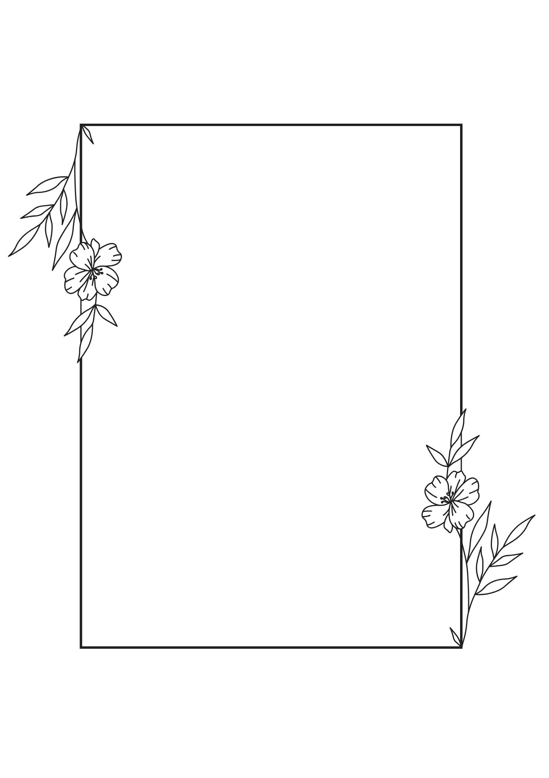
Wedding Day Timeline
A well-structured wedding day timeline ensures your celebration runs smoothly, keeps everyone on track, and allows you to enjoy the day without unnecessary stress. While many couples rely on a wedding planner to prepare a detailed schedule, creating one yourself is absolutely manageable with the right template.
Every wedding is unique, depending on personal priorities, traditions, and ceremony times. The sample timeline below is designed for an evening ceremony and reception, and can be customized to fit your special day.

Sample Wedding Day Schedule
9:00 AM – Hair and makeup begin for bridesmaids, followed by the bride
9:00 AM – Reception setup begins by wedding designer or rental company
11:00 AM – Groom and groomsmen gather to prepare
12:00 PM – Lunch break
1:00 PM – Flowers delivered to bridal suite, groom’s suite, and ceremony/reception sites
2:00 PM – “Getting ready” photos of bride/bridesmaids and groom/groomsmen
3:00 PM – First look photos (if planned)
3:30 PM – Ceremony music begins; guests start arriving; ushers distribute programs
4:00 PM – Wedding party in place
4:30–5:30 PM – Ceremony
5:30–6:30 PM – Cocktail hour; family and wedding party photos
6:30 PM – Grand entrance of bride, groom, and wedding party
6:45 PM – Dinner service begins
7:30 PM – Toasts
8:00 PM – First dance, followed by parent dances (Mother-Son, Father-Daughter)
8:30 PM – Cake cutting
9:00 PM – Bouquet toss
9:45 PM – Last dance
10:00 PM – Bride and groom send-off

