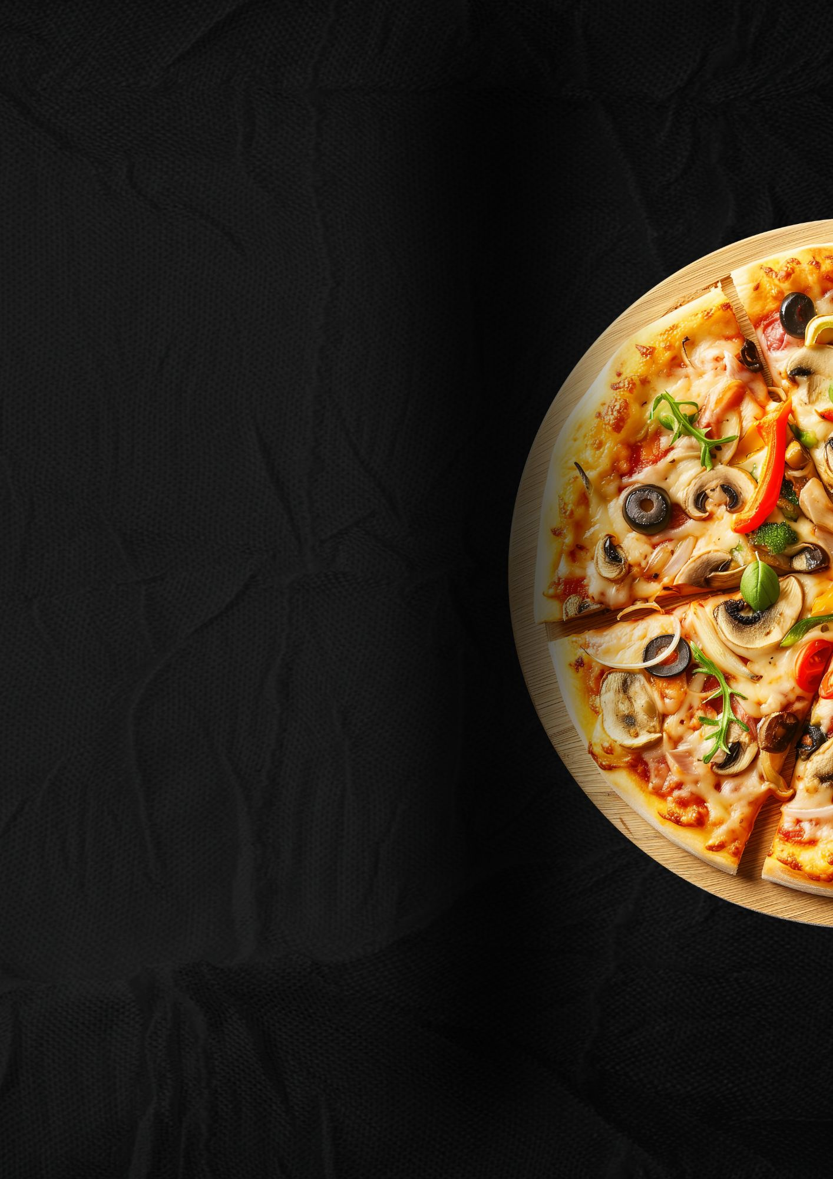
Our Menu

Beef Sausage Pizza $0.0
[Lorem Ipsum is simply dummy text of
the printing and typesetting industry.]

Pizza Menu 2 $0.0
[Lorem Ipsum is simply dummy text of
the printing and typesetting industry.]

Pizza Menu 3 $0.0
[Lorem Ipsum is simply dummy text of
the printing and typesetting industry.]

Pizza Menu 4 $0.0
[Lorem Ipsum is simply dummy text of
the printing and typesetting industry.]

Pizza Menu 5 $0.0
[Lorem Ipsum is simply dummy text of
the printing and typesetting industry.]

[Your Restaurant Name]
Phone: +1 234 567 890
Email: huguetemplate@gmail.com
www.huguetemplate.net

